Section 6.3: Acids and Bases

Acids
Any compound that when dissolved in water forms a solution that;
-Tastes sour (orange juice, lemon juice)
-Corrodes metals
-Can burn tissues (will burn tissues)

examples include Sulphuric Acid (H₂SO₄), Hydrochloric Acid (H₃O⁺ + Cl⁻).

Bases
Any compound that when dissolved in water forms a solution that;
-Tastes BITTER (soda water / tonic water)
-Breaks down oils and fats
-Feels slippery to the touch
-Can burn tissues (will burn tissues)

Both acids and bases are colourless and transparent (solutions).
A base will neutralize an acid, effectively turning into a neutral solution (kind of like water)

You tell the difference between an acid and a base in chemistry by using an ‘indicator’ chemical. An indicator chemical turns a different colour in an acid than it does in a base. The indicator reacts to the “pH” of the solution. Common indicator chemicals include; Thymol blue, Methyl red, Bromothymol blue, and Phenolphthalein. A simple label we use is “litmus paper” (ever hear the term “passing the litmus test” ? It means “did you pass the honesty test?”, or “Did you pass the hard work test?”

pH
The pH scale goes from 1 to 14. Pure water has a pH of 7. If the pH is higher than 7, the solution is considered BASIC (a base) or “alkaline”, while if the pH is less than 7, the solution is considered ACIDIC (an acid). PH measurements can be a decimal, such as 7.8, or 5.2, and we say that “a solution has a pH of 4.5”.

We really do not know what the ‘p’ stands for, but the ‘H’ stands for “hydrogen ion”. Acids require molecules with Hydrogen atoms in them that when dissolved in water split up into H ‘ions’ (atoms missing an electron, or having an extra electron than what they are supposed to have).

See the scale below (and page 175 in textbook):

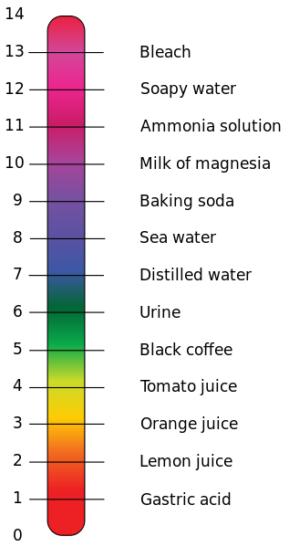

pH of living bits:
pH in living systems
Compartment | pH
Gastric acid | 1
Human skin | 5.5
Urine | 6.0
Pure H₂O at 37 °C | 6.81
Cerebrospinal fluid (CSF) | 7.5
Blood | 7.34–7.45
Pancreas secretions | 8.1

