Section 6.3: Acids and Bases (adapted)

Acids
Any compound that when dissolved in water;
-Tastes sour (orange juice, lemon juice)
-Corrodes metals
-Can burn tissues (will burn tissues)

examples include Sulphuric Acid (H₂SO₄), Hydrochloric Acid (H₃O⁺ + Cl⁻).

Bases
Any compound that when dissolved in water;
-Tastes BITTER (soda water / tonic water)
-Breaks down oils and fats
-Feels slippery to the touch
-Can burn tissues (will burn tissues)

Both acids and bases are colourless and transparent (solutions).
A base will neutralize an acid, turning into a neutral solution (like water)

You tell the difference between an acid and a base in chemistry by using an ‘indicator’ chemical. An indicator turns a different colour in an acid than it does in a base. The indicator reacts to the “pH” of the solution. A common indicator we use is “litmus paper” (ever hear the term “passing the litmus test” ? It means did you pass the honesty test, or “Did you pass the hard work test?”

pH
The pH scale goes from 1 to 14. Pure water has a pH of 7. If the pH is higher than 7, the solution is considered BASIC (a base) or “alkaline”, if the pH is less than 7, the solution is considered ACIDIC (an acid). PH measurements can be a decimal, such as 7.8, or 5.2. We say that “a solution has a pH of 4.5”.

See the scale below (and page 175 in textbook):

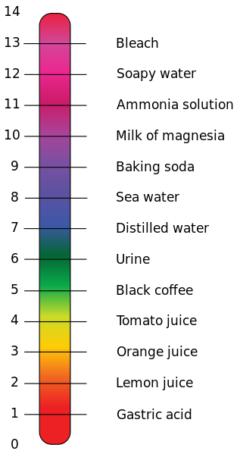

pH of living bits:
pH in living systems
Compartment | pH
Gastric acid | 1
Human skin | 5.5
Urine | 6.0
Pure H₂O at 37 °C | 6.81
Cerebrospinal fluid (CSF) | 7.5
Blood | 7.34–7.45
Pancreas secretions | 8.1

